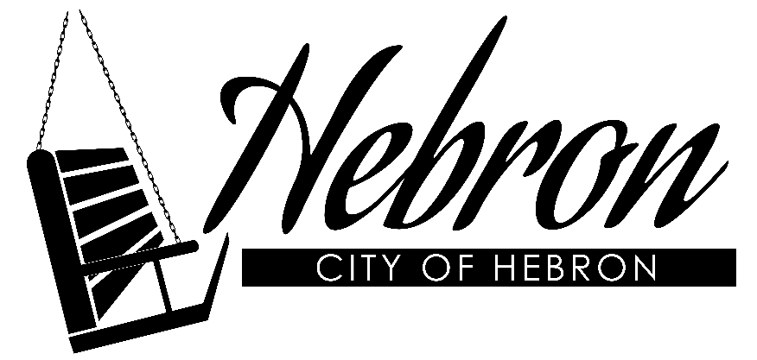

City of Hebron
216 Lincoln Ave.
Hebron, NE 68370
402-768-6322

CITY OF HEBRON PRESS RELEASE
HEBRON, NEBRASKA-In response to the COVID-19 (Coronavirus) pandemic, the City of Hebron has been monitoring various governmental agencies such as the World Health Organization (WHO), Center for Disease Control (CDC), Nebraska State Government, including the Governor’s office, Nebraska’s Department of Health and Human Services (DHHS), Public Health Solutions, and Thayer County Health Solutions.
The CDC has updated their recommendation that groups of 10 or mor people should not gather, especially if the participants are arriving from other communities, which would increase the chances of the virus being transmitted into our community and participants then becoming infected and transmitting it back to their own communities.
“It is important during this time of uncertainty that we remain calm and proactive in protecting our citizens,” said Mayor Doug Huber. “I appreciate everyone’s patience and I encourage our businesses to also listen to the CDC recommendations and keep up to date with the latest information.”
In the interest of public safety, effective 8:00 am on Tuesday, March 17, 2020 the City is cancelling all meetings and gatherings at all City facilities including the Hebron Secrest Library, Hebron Activity Center, Stastny Community Center, and the Hebron Fire Hall. All City Recreation programming is suspended and use of City ballfields and parks for games and practices is prohibited until further notice. All City buildings will be closed to Public access but City staff will be available via telephone to provide services and conduct business. Payments can be dropped in the box outside the City office, paid online at hebronnebraska.us or via phone. Hebron Secrest Library will be open, but will have a maximum of 3 patrons at a time.
The City will continue to provide essential services such as electric, water, wastewater, police, fire, and EMS.
For general information please contact City Hall at 402-768-6322.
*For the latest local healthcare updates please go to the Thayer County Health Services website at: thayercountyhealth.com – At the bottom of their COVID-19 page are links to other important sources as well.

