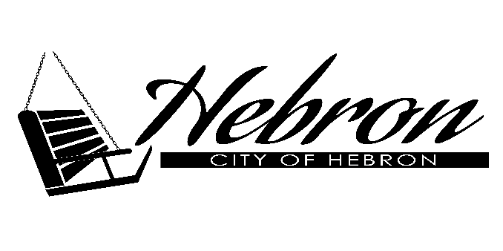 | 216 Lincoln Ave.  Hebron, NE 68370  402 768 6322  www.hebronnebraska.us

Employment Application for Summer Help

Applicant Information
Full Name: |  |  |  | Date:
 | Last | First | M.I.

Address:
 | Street Address | Apartment/Unit #

 | City | State | ZIP Code

Phone: |  | Email

Date Available: |  | Social Security No.: |  | Date of Birth:

Position Applied for:

Are you a citizen of the United States? | YES | NO | If no, are you authorized to work in the U.S.? | YES | NO

Have you ever worked for this company? | YES | NO | If yes, when?

Have you ever been convicted of a felony? | YES | NO

If yes, explain:

References
Please list three professional references.
Full Name: |  | Relationship:
Company: |  | Phone:
Address:
Full Name: |  | Relationship:
Company: |  | Phone:
Address:
Full Name: |  | Relationship:
Company: |  | Phone:
Address:

Disclaimer and Signature
I certify that my answers are true and complete to the best of my knowledge.
If this application leads to employment, I understand that false or misleading information in my application or interview may result in my release.
Signature: |  | Date:

The city is an equal opportunity employer and shall not discriminate in its employment practices and policies with respect to hiring, compensation, terms, conditions, or privileges of employment because of such individual’s race, color, religion, sex, age or national origin.

