Hebron Parks and Recreation
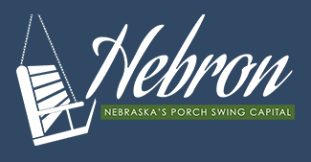

Summer Rec Advertisement 2024
The City of Hebron and the Parks and Rec Board are looking for applicants to help coordinate summer recreation. There are three areas of interest to include: field prep and maintenance, coordinating the concession stands, and coordinating / scheduling league games and umpires. If any or all these activities sound appealing to you, please inquire at the City Office today! Applicants may apply for one or more areas of interest mentioned above. Pay and hours to be determined. Please apply by March 5th. Don’t miss the opportunity to support our community’s recreational programming and to enjoy some summer leisure fun!

Summer Rec Job Descriptions 2024
- Field Prep and Maintenance – This individual will be responsible for the general field maintenance. This may include, but is not limited to mowing, spraying, dragging, and prepping the ball fields for play; and coordinating mowing for the other areas of the Rec Complex and CC Camp. They will also practice oversight and management of any summer recreation employees designated to assist with the fields and mowing.
- Concession Stand Coordinator – This individual will be responsible for the general oversight of the concession stands. This will include, but may not be limited to ordering, inventorying, scheduling, and cleaning the Summer Rec Concession areas. They will also practice oversight and management of any summer recreation employees designated to assist with concessions.
- League / Umpire Scheduling Coordinator – This individual will be responsible for scheduling and coordinating teams and umpires for the summer ball season. This will also include managing ball and uniform inventory as appropriate.

*The Parks and Recreation Board has recommended a split of the position in hopes that we may recruit additional interest. We will consider individuals for each responsibility listed above, individuals interested in a combination of any of the responsibilities; or individuals interested in all the responsibilities. By advertising it this way, we feel we at least have a better shot of trying to cover all the responsibilities and hopefully set ourselves up for a successful 2024 season. Any potential applicants and suggested pay will be recommended to the council after the ad closes, and we know what we are working with.

